Regular Tetrahedron

Definition
# Source: AI Source: Provided by: [Data Path: Persons Table -> ID Column: 1, Name_En Column: Motasem Essam] -> From: [ChatGPT] on [7/25/2026]
A regular tetrahedron is a three-dimensional geometric solid consisting of four congruent equilateral triangular faces. All six edges have equal lengths, and all four vertices are geometrically equivalent.
It is a special type of triangular pyramid and one of the five Platonic solids. Each face is an equilateral triangle, and exactly three faces meet at every vertex.
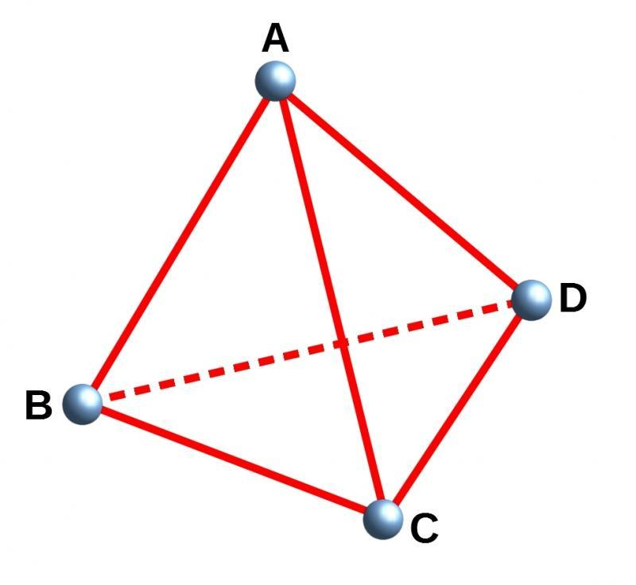
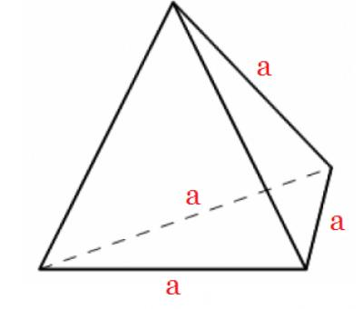

Simple Definition
# Source: AI Source: Provided by: [Data Path: Persons Table -> ID Column: 1, Name_En Column: Motasem Essam] -> From: [ChatGPT] on [7/25/2026]
A regular tetrahedron is a triangular pyramid with four identical equilateral triangular faces and six equal edges.
Unlike a general triangular pyramid, it has the same shape and size on every face.

Key Characteristics
# Source: AI Source: Provided by: [Data Path: Persons Table -> ID Column: 1, Name_En Column: Motasem Essam] -> From: [ChatGPT] on [7/25/2026]
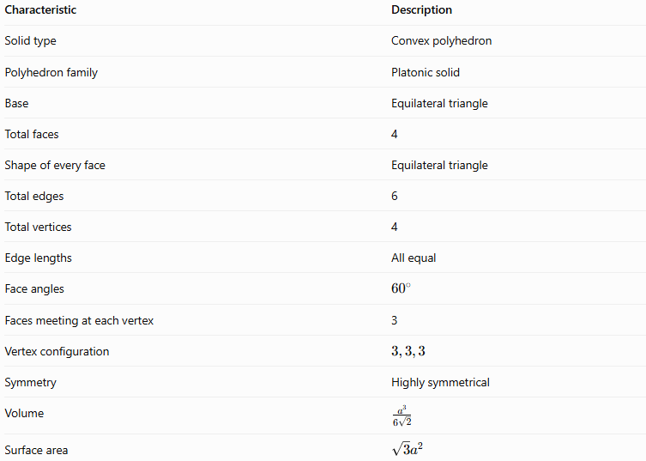
Characteristic | Description
Solid type | Convex polyhedron
Polyhedron family | Platonic solid
Base | Equilateral triangle
Total faces | 4
Shape of every face | Equilateral triangle
Total edges | 6
Total vertices | 4
Edge lengths | All equal
Face angles | $${60}^{∘}$$
Faces meeting at each vertex | 3
Vertex configuration | $$3,3,3$$
Symmetry | Highly symmetrical
Volume | $$\frac{a^{3}}{6\sqrt{2}}$$
Surface area | $$\sqrt{3}a^{2}$$
Here, $a$ is the common edge length.

Geometric Representation
# Source: AI Source: Provided by: [Data Path: Persons Table -> ID Column: 1, Name_En Column: Motasem Essam] -> From: [ChatGPT] on [7/25/2026]
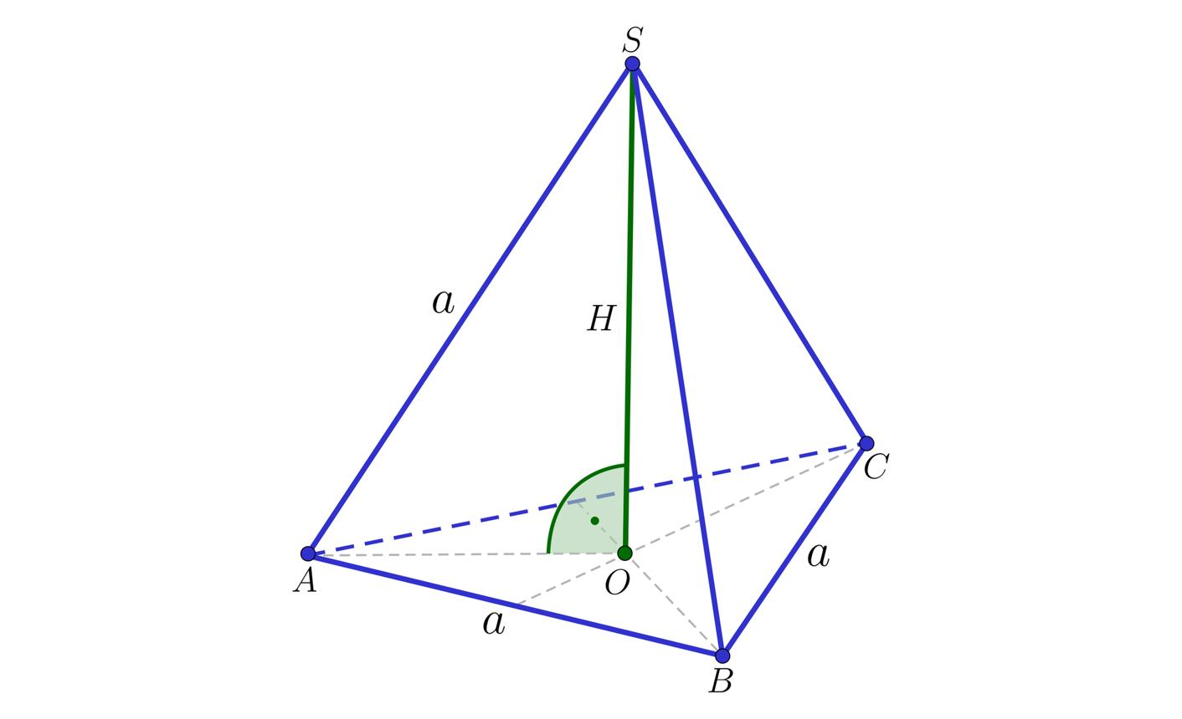
Consider a regular tetrahedron $ABCD$.
Its components are:
- Base $ABC$: An equilateral triangle.
- Apex $D$: The vertex opposite the chosen base.
- Base edges: $AB$, $BC$, and $CA$.
- Lateral edges: $AD$, $BD$, and $CD$.
- Lateral faces: Triangles $ABD$, $BCD$, and $CAD$.
- Total faces: The base and three lateral faces, giving four equilateral triangles.
- Height $h$: The perpendicular distance from vertex $D$ to the plane containing triangle $ABC$.
The choice of base is arbitrary: any of the four faces can serve as the base, and the remaining vertex becomes the apex.

Mathematical Representations and Formulas
# Source: AI Source: Provided by: [Data Path: Persons Table -> ID Column: 1, Name_En Column: Motasem Essam] -> From: [ChatGPT] on [7/25/2026]
Let:
- $a$ = common edge length
- $h$ = perpendicular height
- $A_{f}$ = area of one triangular face
- $A_{T}$ = total surface area
- $V$ = volume

A. Number of faces, edges, and vertices
# Source: AI Source: Provided by: [Data Path: Persons Table -> ID Column: 1, Name_En Column: Motasem Essam] -> From: [ChatGPT] on [7/25/2026]
A regular tetrahedron has:
$$\boxed{F=4, E=6, V_{e}=4}$$
Euler's formula confirms these counts:
$$V_{e}-E+F=4-6+4=2$$

B. Area of one face
# Source: AI Source: Provided by: [Data Path: Persons Table -> ID Column: 1, Name_En Column: Motasem Essam] -> From: [ChatGPT] on [7/25/2026]
Each face is an equilateral triangle, so:
$$A_{f}=\frac{\sqrt{3}}{4}a^{2}$$

C. Total surface area
# Source: AI Source: Provided by: [Data Path: Persons Table -> ID Column: 1, Name_En Column: Motasem Essam] -> From: [ChatGPT] on [7/25/2026]
There are four congruent faces:
$$A_{T}=4A_{f}$$
Therefore:
$$\boxed{A_{T}=\sqrt{3}a^{2}}$$

D. Perpendicular height
# Source: AI Source: Provided by: [Data Path: Persons Table -> ID Column: 1, Name_En Column: Motasem Essam] -> From: [ChatGPT] on [7/25/2026]
The apex lies directly above the centroid of the equilateral base. The distance from the base centroid to a base vertex is $a/\sqrt{3}$.
Using the Pythagorean theorem:
$$h^{2}+{\left(\frac{a}{\sqrt{3}}\right)}^{2}=a^{2}$$
Therefore:
$$h^{2}=a^{2}-\frac{a^{2}}{3}=\frac{2a^{2}}{3}$$
Thus:
$$\boxed{h=a\sqrt{\frac{2}{3}}=\frac{\sqrt{6}}{3}a}$$

E. Volume
# Source: AI Source: Provided by: [Data Path: Persons Table -> ID Column: 1, Name_En Column: Motasem Essam] -> From: [ChatGPT] on [7/25/2026]
The volume of a pyramid is one-third the base area multiplied by its perpendicular height:
$$V=\frac{1}{3}Bh$$
The base area is:
$$B=\frac{\sqrt{3}}{4}a^{2}$$
Substituting the height:
$$V=\frac{1}{3}\left(\frac{\sqrt{3}}{4}a^{2}\right)\left(\frac{\sqrt{6}}{3}a\right)$$
After simplification:
$$\boxed{V=\frac{\sqrt{2}}{12}a^{3}=\frac{a^{3}}{6\sqrt{2}}}$$

F. Dihedral angle
# Source: AI Source: Provided by: [Data Path: Persons Table -> ID Column: 1, Name_En Column: Motasem Essam] -> From: [ChatGPT] on [7/25/2026]
The interior dihedral angle is the angle between two faces along a shared edge. For a regular tetrahedron:
$$\boxed{θ=\cos^{-1}\left(\frac{1}{3})\right.}$$
$$θ≈{70.53}^{∘}$$
This differs from the ${60}^{∘}$ interior angles within each triangular face.

Worked Examples
# Source: AI Source: Provided by: [Data Path: Persons Table -> ID Column: 1, Name_En Column: Motasem Essam] -> From: [ChatGPT] on [7/25/2026]
Example 1: Finding the total surface area
Problem: A regular tetrahedron has an edge length of $6\text{ cm}$. Find its total surface area.
Solution:
$$A_{T}=\sqrt{3}a^{2}$$
$$A_{T}=\sqrt{3}{\left(6\right)}^{2}=36\sqrt{3}$$
$$\boxed{A_{T}≈62.35{\text{ cm}}^{2}}$$
Example 2: Calculating the height
Problem: Find the perpendicular height of a regular tetrahedron with an edge length of $3\text{ cm}$.
Solution:
$$h=\frac{\sqrt{6}}{3}a$$
$$h=\frac{\sqrt{6}}{3}\left(3\right)$$
$$\boxed{h=\sqrt{6}\text{ cm}≈2.45\text{ cm}}$$
Example 3: Calculating the volume
Problem: Find the volume of a regular tetrahedron with an edge length of $6\text{ cm}$.
Solution:
$$V=\frac{a^{3}}{6\sqrt{2}}$$
$$V=\frac{6^{3}}{6\sqrt{2}}=\frac{36}{\sqrt{2}}$$
Rationalizing the denominator:
$$\boxed{V=18\sqrt{2}{\text{ cm}}^{3}≈25.46{\text{ cm}}^{3}}$$
Example 4: Verifying Euler's formula
A regular tetrahedron has four vertices, six edges, and four faces.
$$V_{e}-E+F=4-6+4$$
$$\boxed{2=2}$$
Therefore, it satisfies Euler's formula for convex polyhedra.

Comparison with Related Geometric Solids
# Source: AI Source: Provided by: [Data Path: Persons Table -> ID Column: 1, Name_En Column: Motasem Essam] -> From: [ChatGPT] on [7/25/2026]
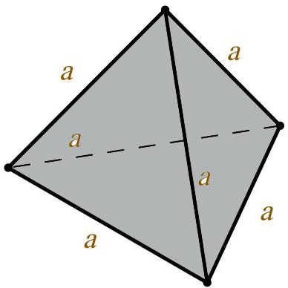
Regular Tetrahedron
- Four equilateral triangular faces.
- Six equal edges.
- Four vertices.
- One of the five Platonic solids.
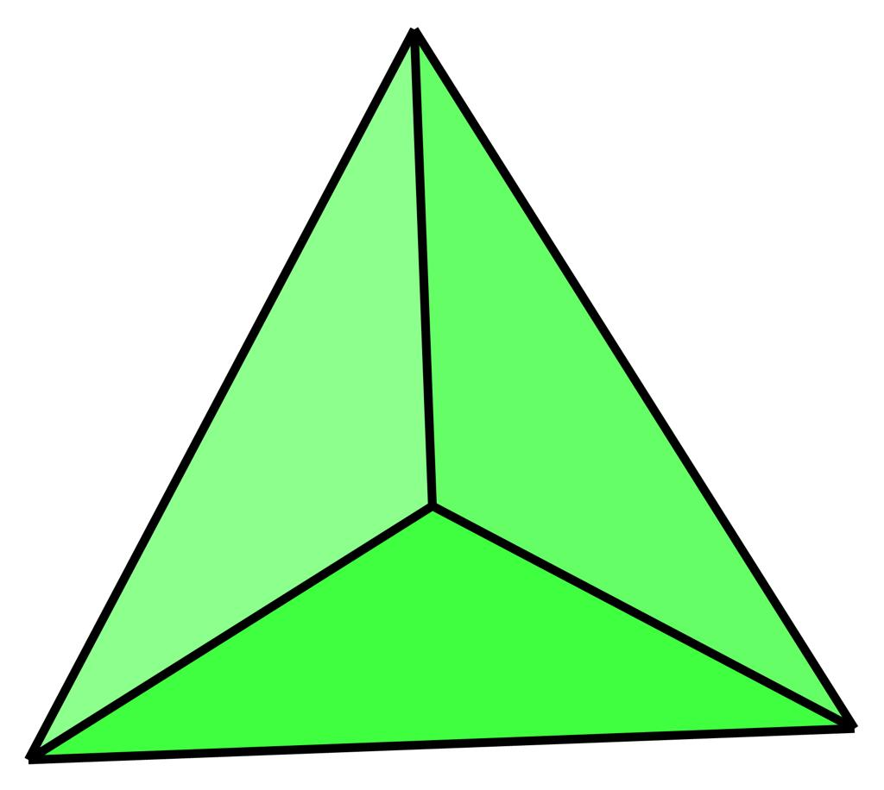
Irregular Triangular Pyramid
- Four triangular faces.
- Edges and faces need not be equal.
- May have an equilateral base without being a regular tetrahedron.
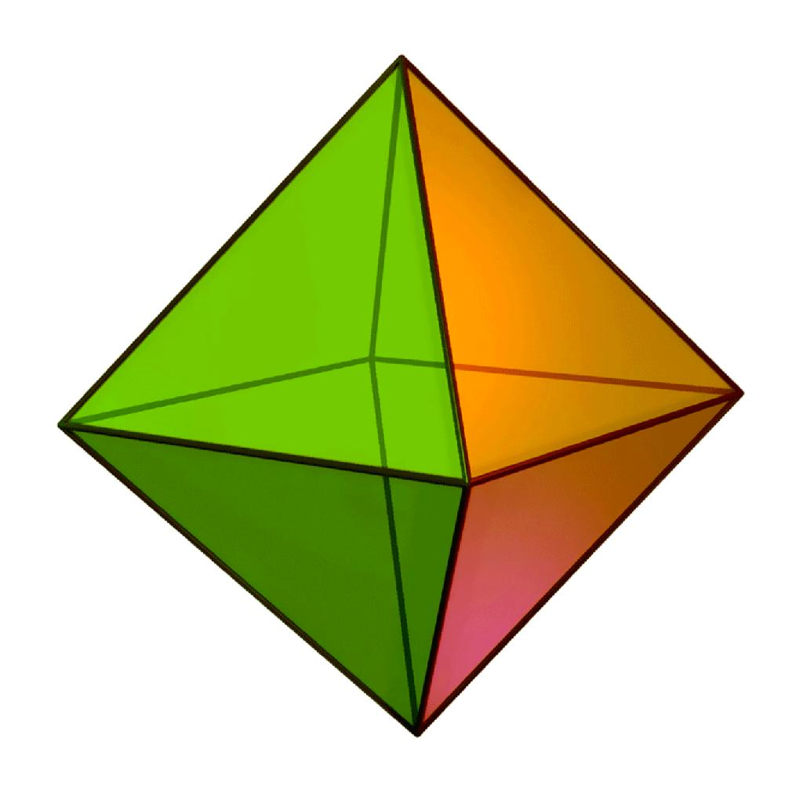
Regular Octahedron
- Eight equilateral triangular faces.
- Twelve equal edges.
- Six vertices.
- Another Platonic solid, with more faces than a tetrahedron.

Applications
# Source: AI Source: Provided by: [Data Path: Persons Table -> ID Column: 1, Name_En Column: Motasem Essam] -> From: [ChatGPT] on [7/25/2026]
Regular tetrahedra are used in:
- Architecture and structural design: Creating triangular frameworks and stable geometric arrangements.
- Chemistry: Representing tetrahedral molecular geometry, such as the arrangement of bonds around a central carbon atom in methane.
- Computer graphics: Constructing meshes, modeling polyhedra, and subdividing three-dimensional objects.
- Mathematics education: Studying symmetry, surface area, volume, and Platonic solids.
- Engineering and fabrication: Designing tetrahedral frames and modular structures.

Key Points
# Source: AI Source: Provided by: [Data Path: Persons Table -> ID Column: 1, Name_En Column: Motasem Essam] -> From: [ChatGPT] on [7/25/2026]
- A regular tetrahedron is a special type of triangular pyramid.
- All four faces are congruent equilateral triangles.
- All six edges have the same length.
- It has four faces, six edges, and four vertices.
- Its surface area is $A_{T}=\sqrt{3}a^{2}$.
- Its height is $h=\frac{\sqrt{6}}{3}a$.
- Its volume is $V=\frac{a^{3}}{6\sqrt{2}}$.
- It is one of the five Platonic solids.
- The ${60}^{∘}$ angles belong to its triangular faces, whereas the angle between two faces is approximately ${70.53}^{∘}$.

Conclusion
# Source: AI Source: Provided by: [Data Path: Persons Table -> ID Column: 1, Name_En Column: Motasem Essam] -> From: [ChatGPT] on [7/25/2026]
A regular tetrahedron is the most symmetrical form of a triangular pyramid. Its four congruent equilateral triangular faces and six equal edges give it a uniform structure in which every vertex and face has an equivalent geometric role. Its simple formulas for surface area, height, and volume make it an important solid in geometry, while its symmetry connects it to Platonic solids, molecular geometry, and three-dimensional modeling.

